

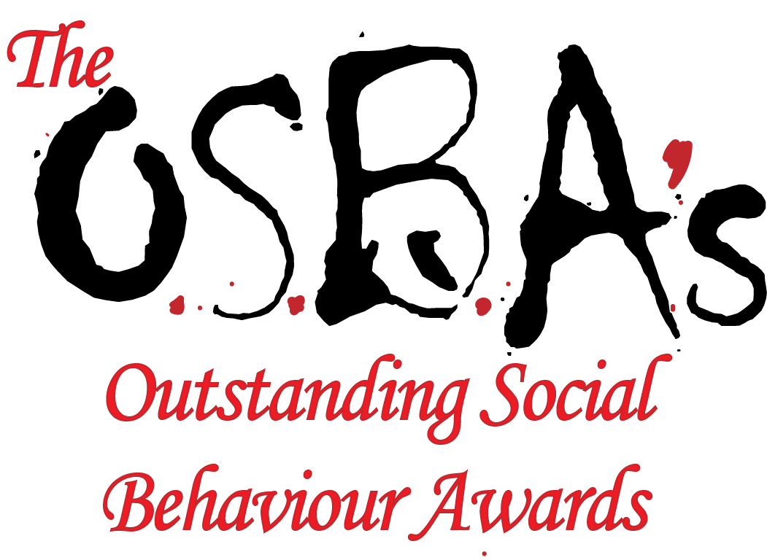

2021 Nomination Form

The OSBAs is about generating good news, showing the world another side to communities affected by gun, knife and gang violence, one of positivity, creativity and fun!



These awards are to recognise and reward outstanding contributions to peace and positive community life in Greater Manchester. There are six categories for which nominations can be made.

* Nominations can be submitted by anyone who lives or works in Greater Manchester provided that he or she is acquainted with the work of the nominee and has permission from the nominee to submit their name/activities for an award.
* Any individual or organisation can be nominated (self-nominations are accepted) providing that they are resident or based in Greater Manchester and have been carrying out their activity for a minimum of 6 months.
* Nominations can only be made by submitting an official nomination form. Copies can be downloaded from [www.theosbas.uk](http://www.theosbas.uk) or by contacting [info@carisma.me.uk](mailto:info@carisma.me.uk).
* All nominations must be submitted on or before the closing date of, February 14th, 2021.
* The information provided will be disclosed only to the judges and Carisma staff/officers on a strictly confidential basis.
* The judges will draw up a shortlist of finalists in each category. All finalists, along with selected runners-up, will be given a ticket plus one free guest ticket to the Awards Dinner (Covid permitting). There may be the opportunity to purchase extra guests tickets.
* The winners will be announced at the Awards Dinner in March 2021. The decision of the judges is final and no correspondence will be entered into before or after the judging.

**Award Categories** (Please tick the award category you wish to nominate for)

**__ Community Cohesion/Diversity Award:** Individual or group who have been instrumental in bringing together diverse groups in the community for positive change

__ **Young Person’s Award:** Young person (aged 11-18) who has made an outstanding contribution to their school or community

__ **Positive Role model Award:** Person who has had most positive affect on young people through their lives.

__ **Turn Around Award:** Individual who has made greatest turnaround in attitude/behaviour to benefit his/her community

**_**_ **Peace Activist Award:** Person or group who have made a difference through campaigning for peace and justice.

__ **Manchester Peace Award:** Individual who has made the most outstanding contribution to their community

**About the nominee:**

First name: ……………………………………. ………………………………………….

Nominee Address: **………………………………………………………………………..**

Postcode Nominee Phone:

Nominee Email ……………………………………………………………………………

Terms and Conditions: (1) Carisma reserves the right to make enquiries about nominations and this may include references from local agencies or organisations acquainted with the activity. (2) Nominations can be submitted for nominees in more than one category providing that the activity described is different in each category and is relevant for the specified category. (3) Write clearly in black ink or type as illegible nominations will not be considered. (4) The organisers reserve the right to cancel any categories or add new categories as they see fit, and not to make awards in any category if the standard of entry does not warrant it (5) The organisers are not obliged to justify the decisions of the judging panel. (6) The organisers will not be responsible for entries which may be damaged, lost or mislaid in the post. Once received, entries remain the property of the organisers. (7) All nominees must be prepared to receive media coverage and this should be accepted as a condition of entry. (8) The organisers reserve the right to publish general material about the winners as case studies of peace champions. (9) The Awards are not open to any employees or officers of Carisma.

|  |  |  |
| --- | --- | --- |
| For Offical use only | Reference Number | Award Category  **Peace Activist** |

|  |
| --- |
| In no more than 150 words, please describe why the nominee deserves an award |
|  |

|  |
| --- |
| In no more than 100 words, please describe the activity the nominee is involved in that has led to this nomination |
|  |

|  |
| --- |
| In no more than 250 words give specific examples of the effect or benefit of the nominee’s actions or activities |
|  |

Declaration (to be signed by the person completing the form)

__ I hereby certify that the information given on this form is correct

__ I agree to the terms and conditions of submitting a nomination for the Peace Awards

Your name Relationship to the nominee: ………………

Your email: …………………………………… Your phone number: ………………………..

Signature: ………………………………………… Date: ………………………………………….

RETURN ENTRIES BY **14th FEBRUARY, 2021** To: CARISMA Services email: [info@carisma.me.uk](mailto:info@carisma.me.uk)